Front-End Demonstration
Pages Built
Manager Features :
- Login
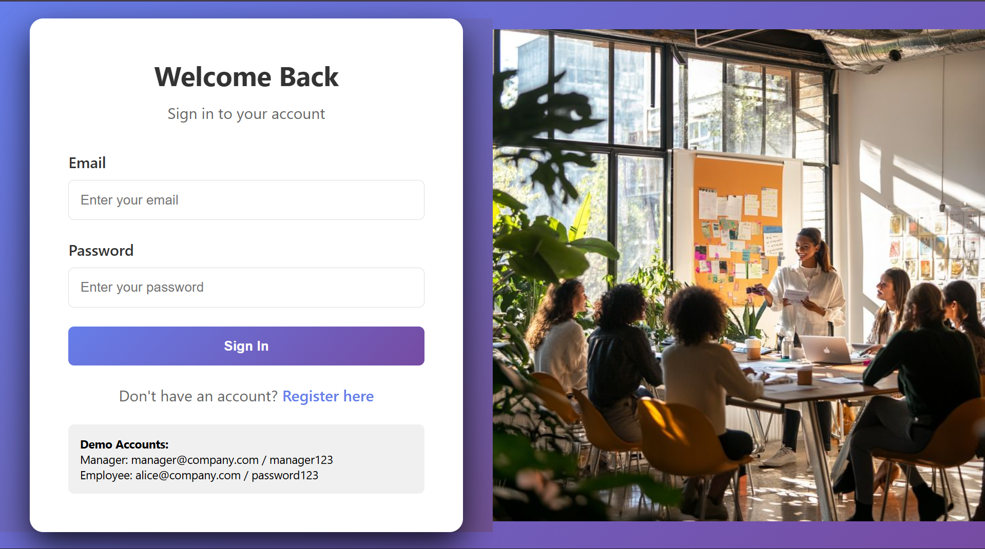

● Dashboard
Main Dashboard with team statistics
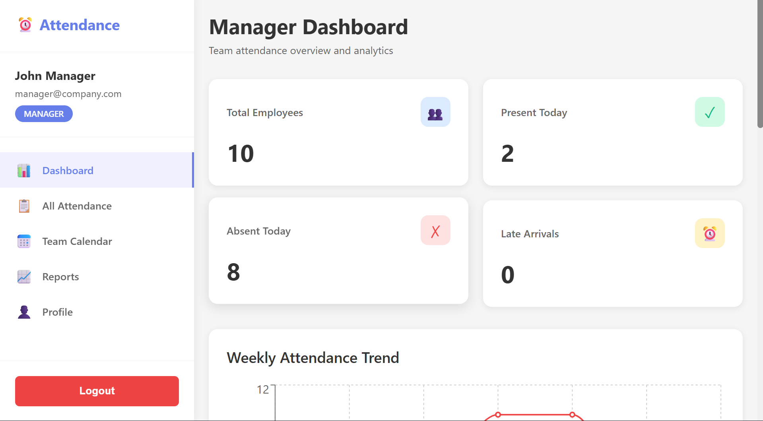
Weekly Trends
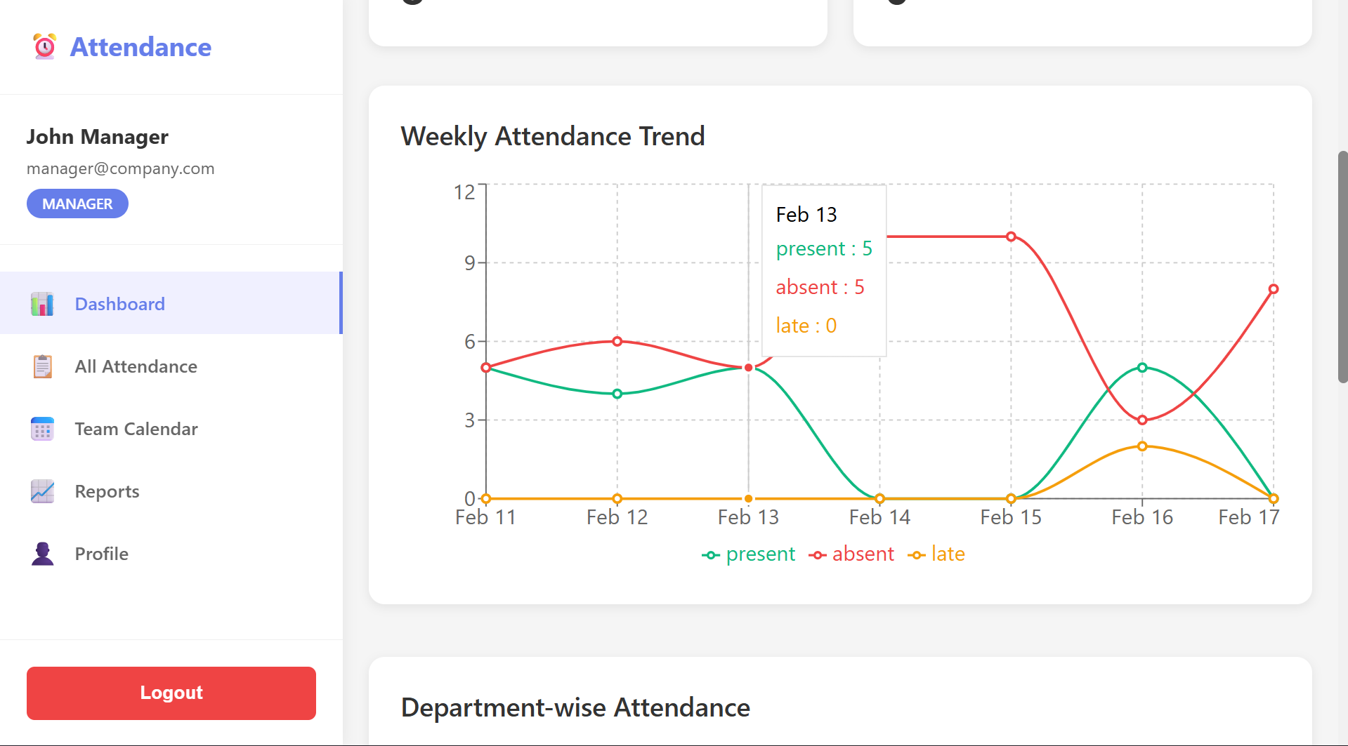

Department-wise Attendance
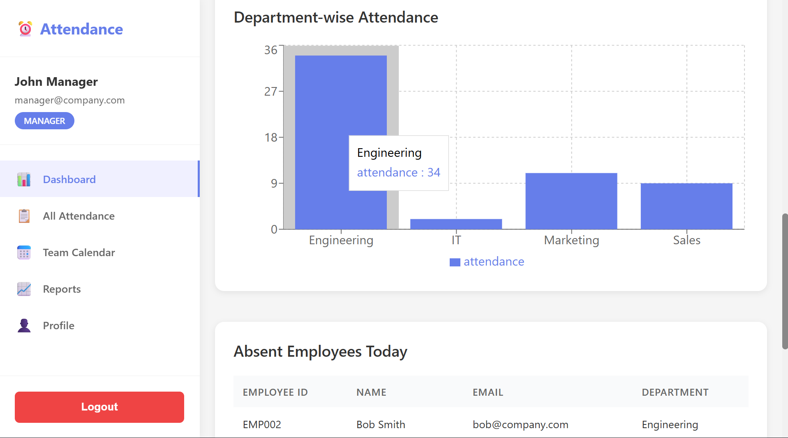

Employees Absent Today
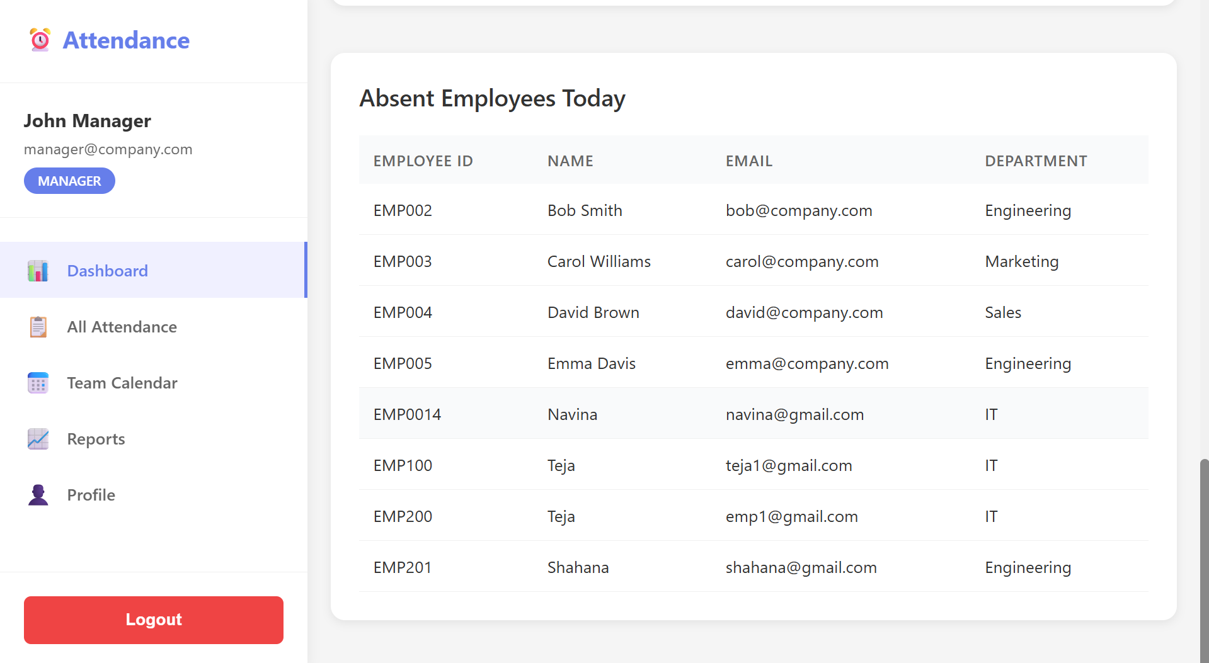

- View all employees attendance and Filter by employee, date, status
Filters implementation
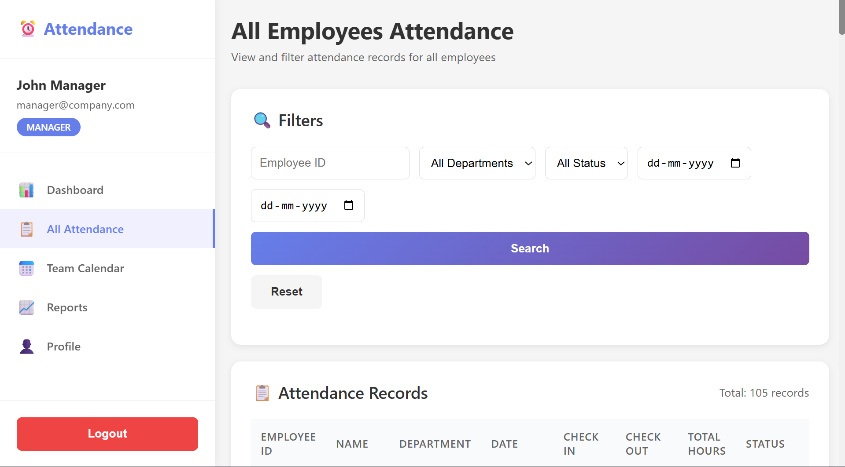

View of all employees records
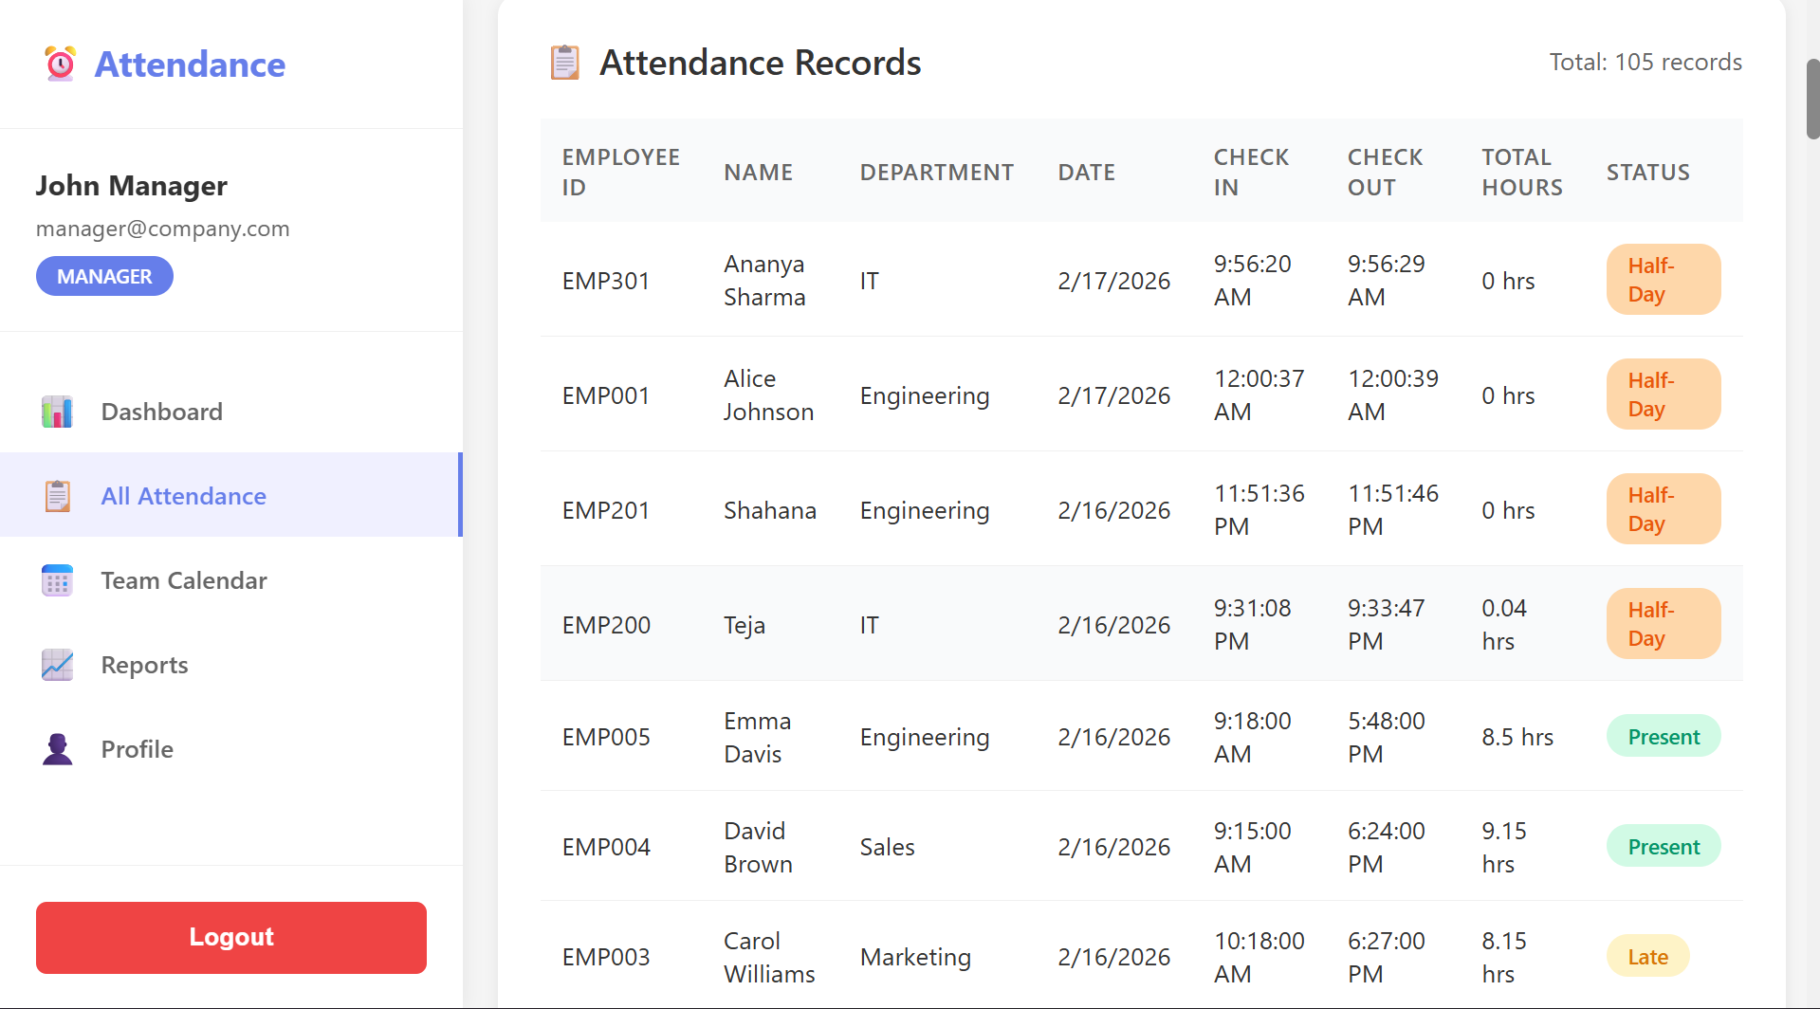
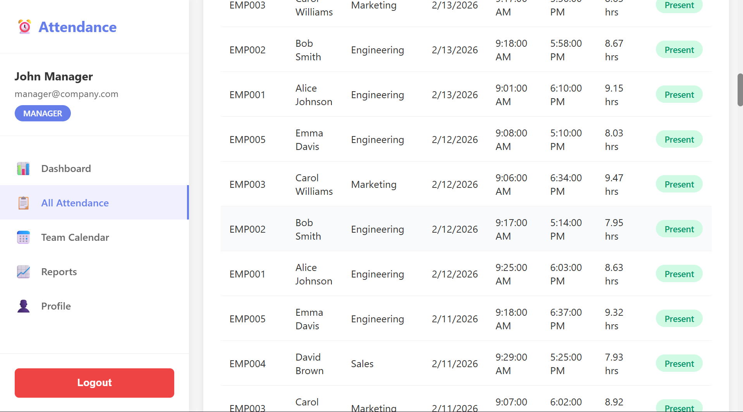

Attendance records along with details like employee ID, name , department , date, check-in, check-out , total hours and the attendance status are shown.

- View team attendance summary
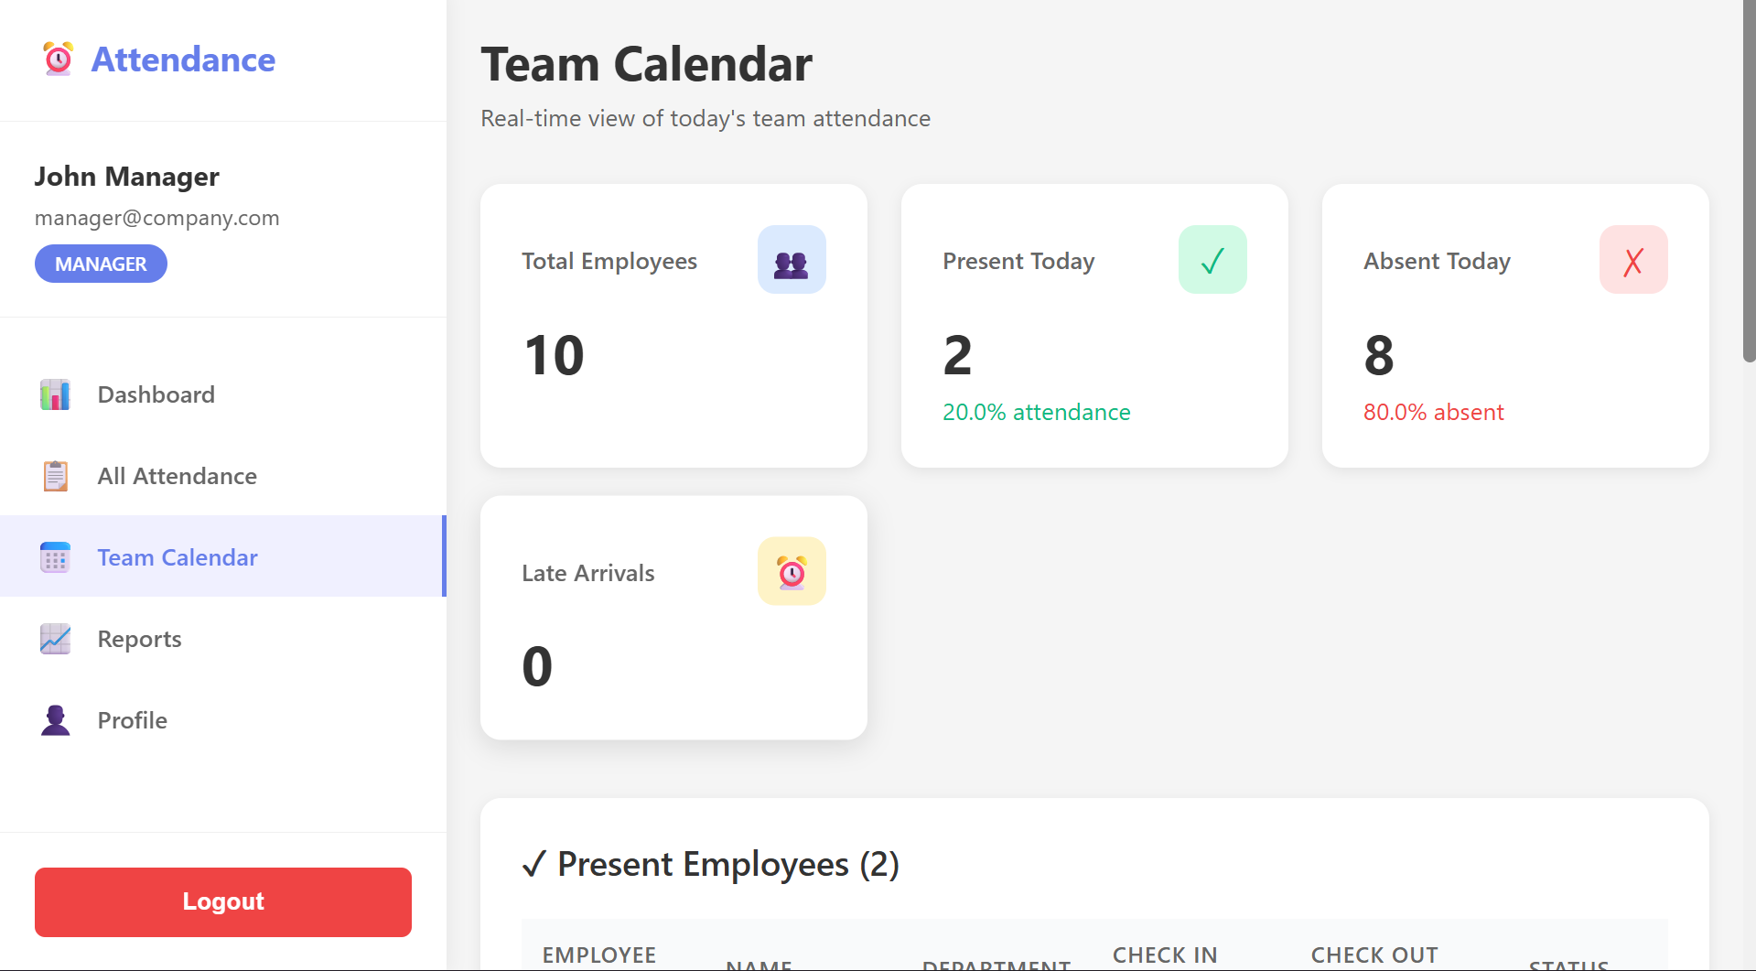
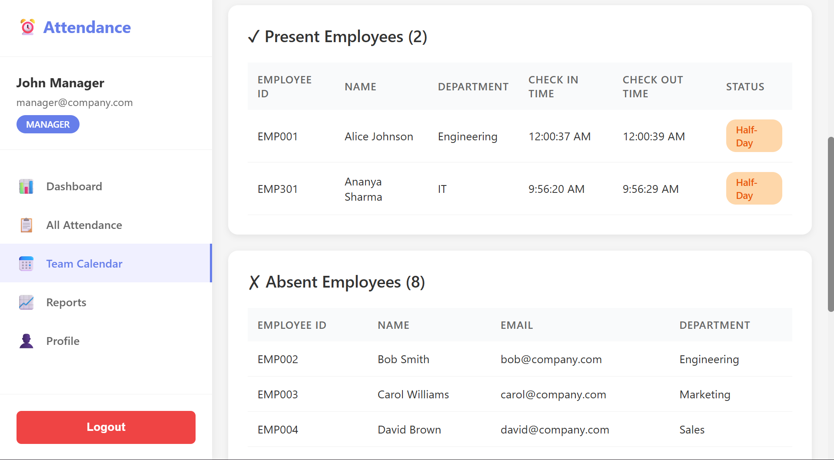
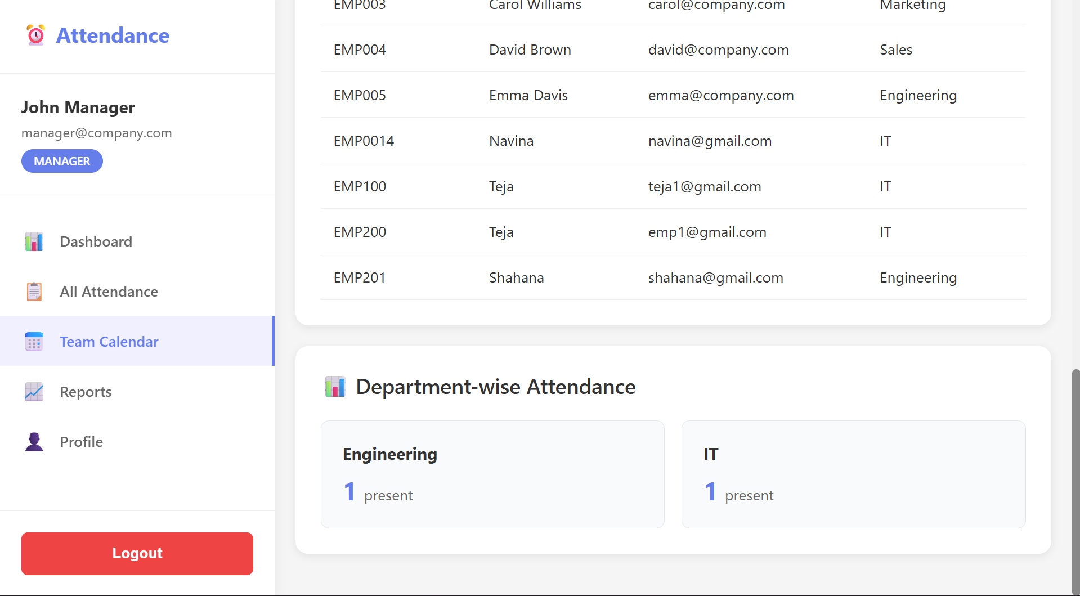

- Export attendance reports (CSV)
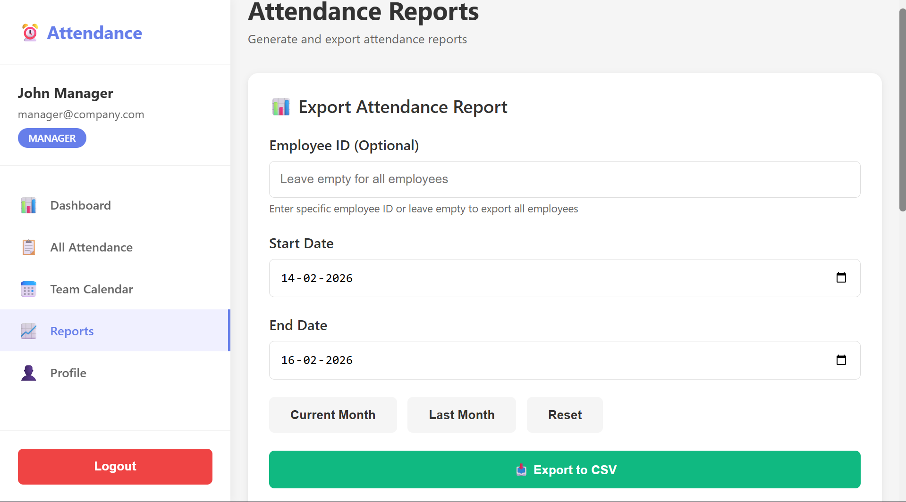
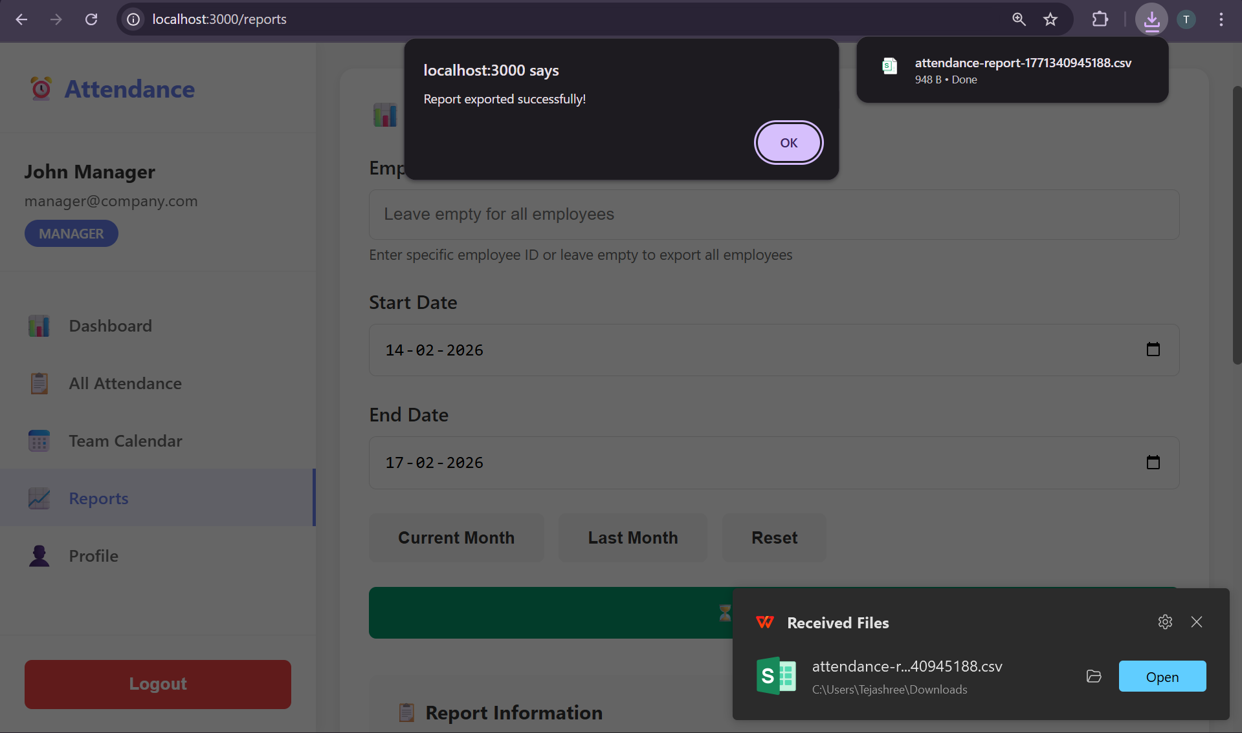
Downloaded report
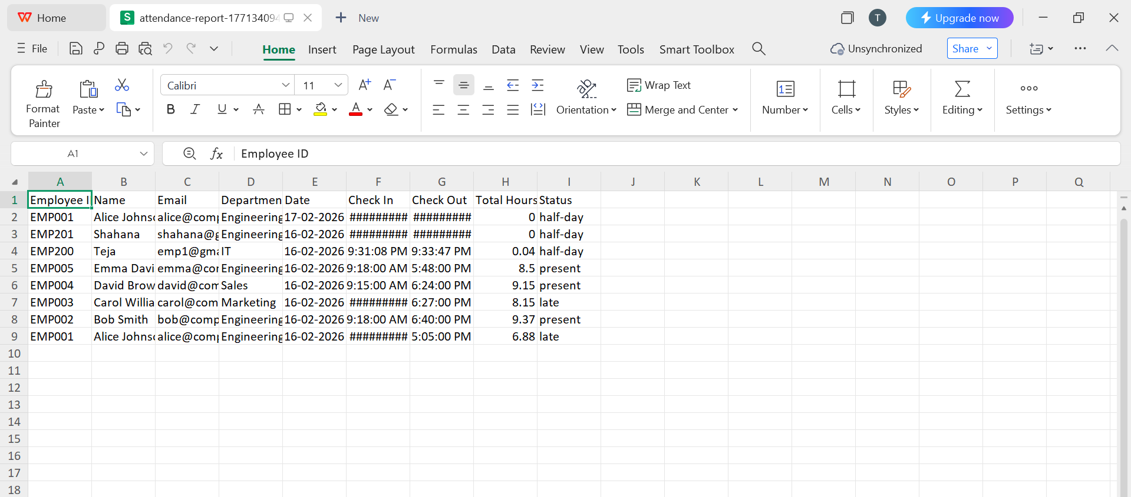
Profile
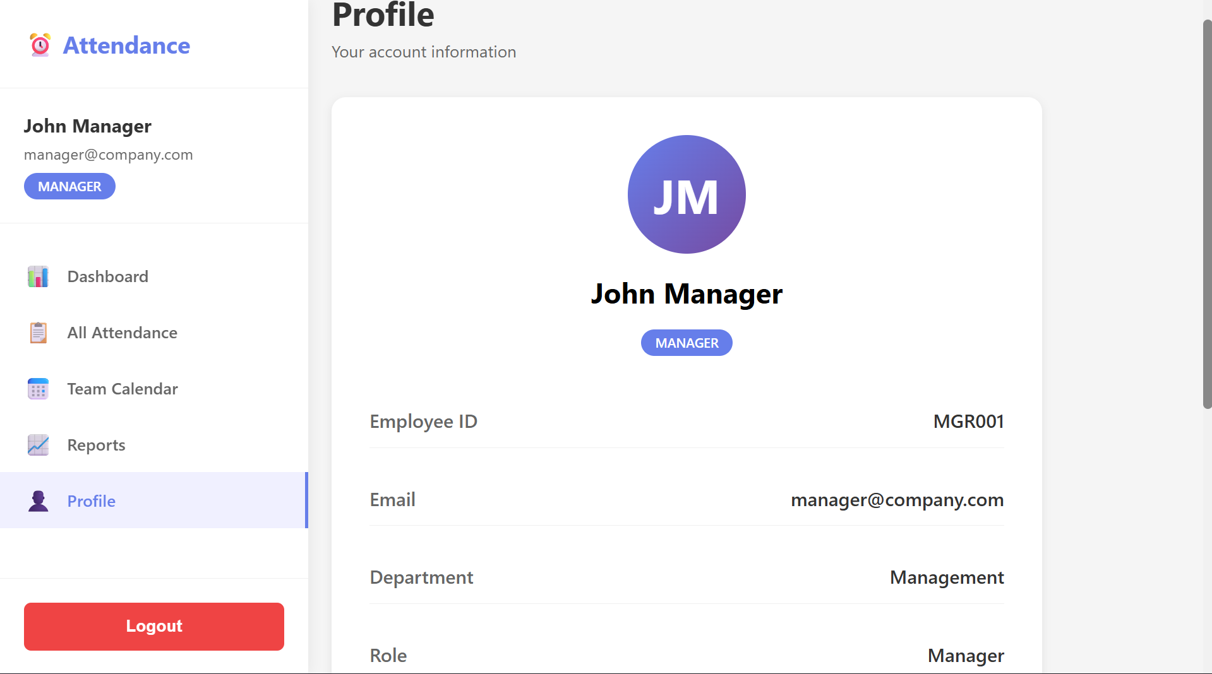
Employee Features
- Login


Register
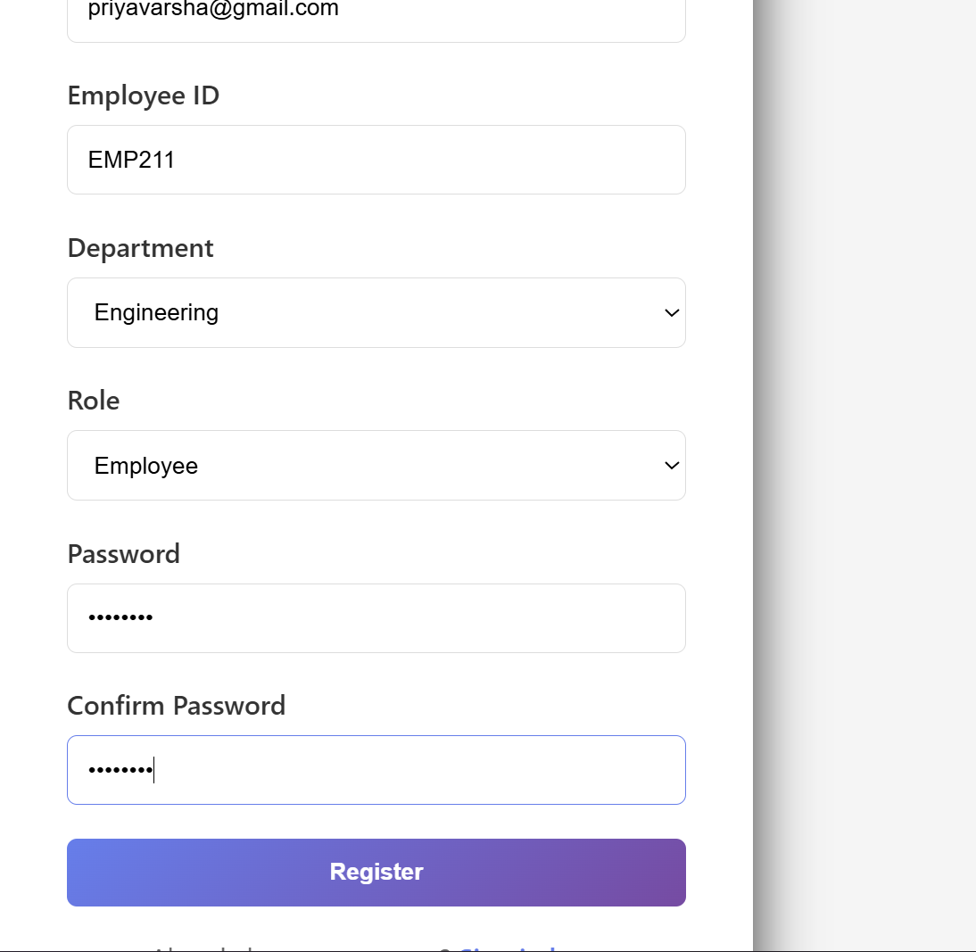

Duplicate Employee ID validation
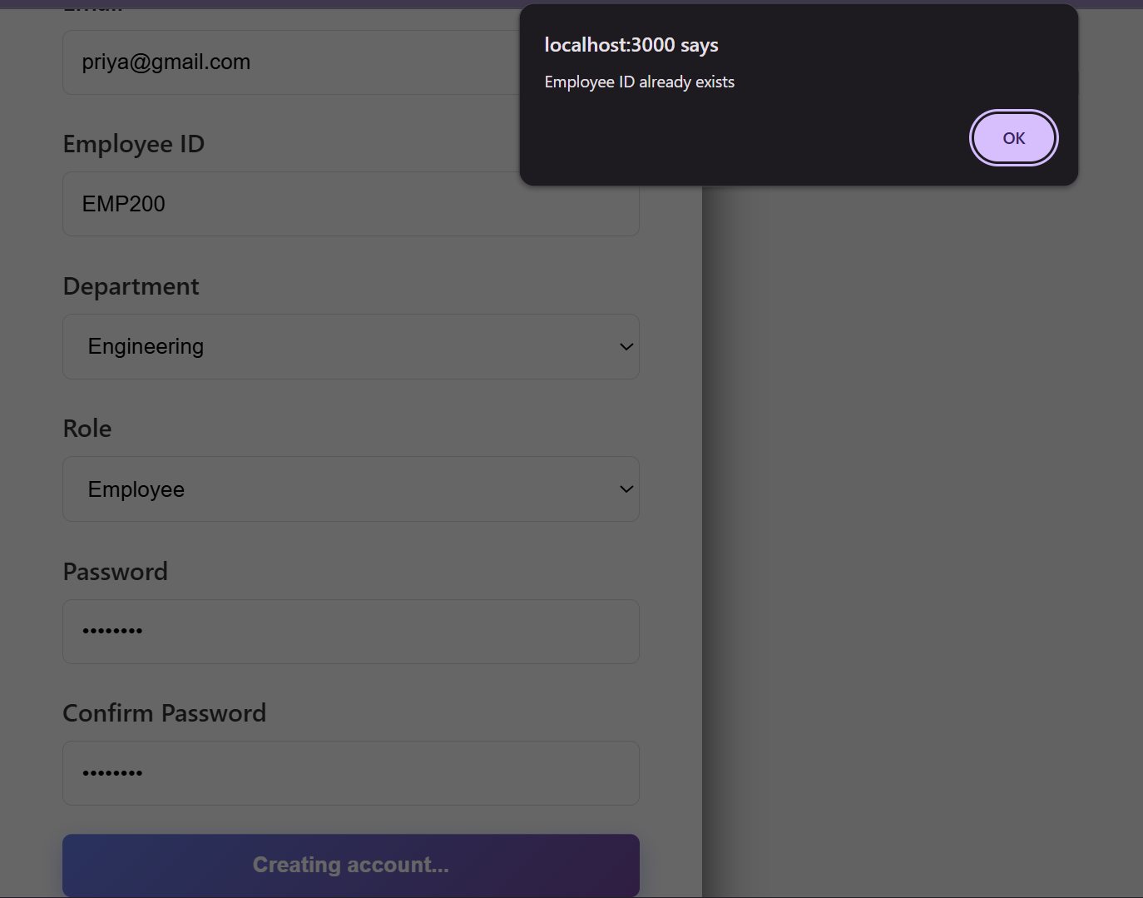

2. Mark attendance (Check In / Check Out)
Attendance data of new user / Daily Check-in Check-out process
Check-in button
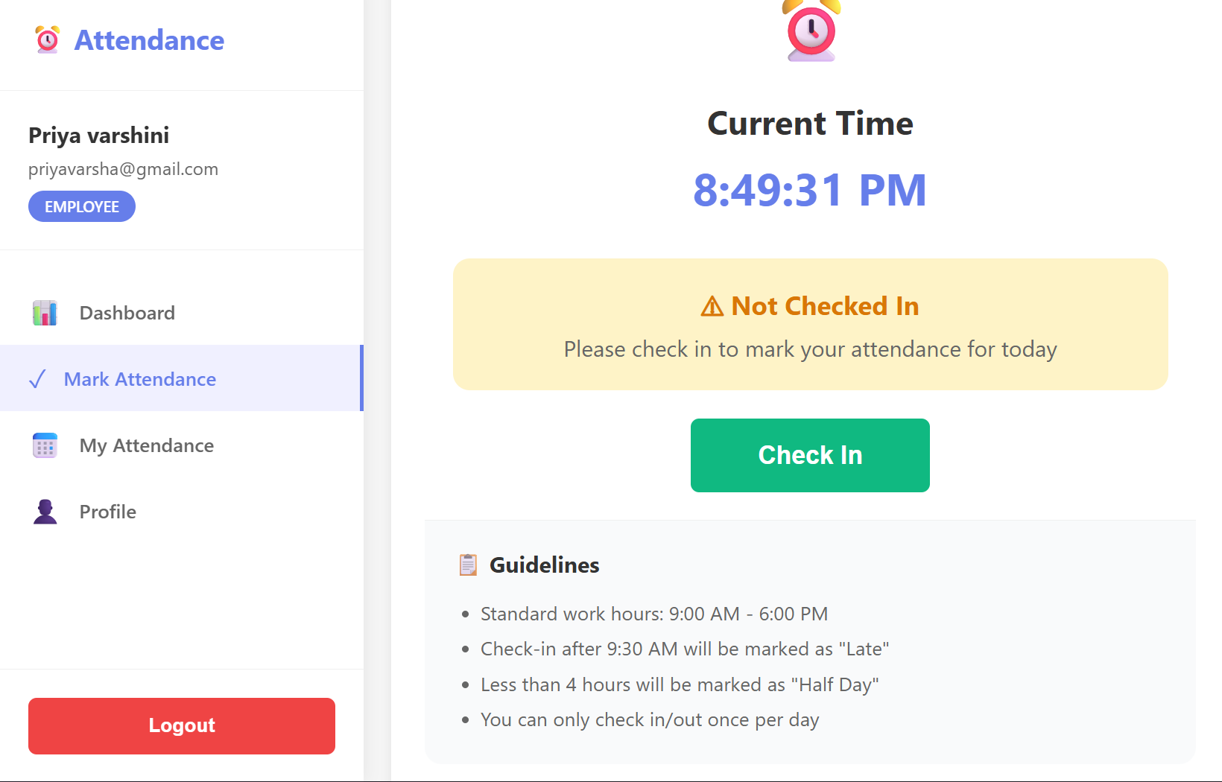

Check-out Button
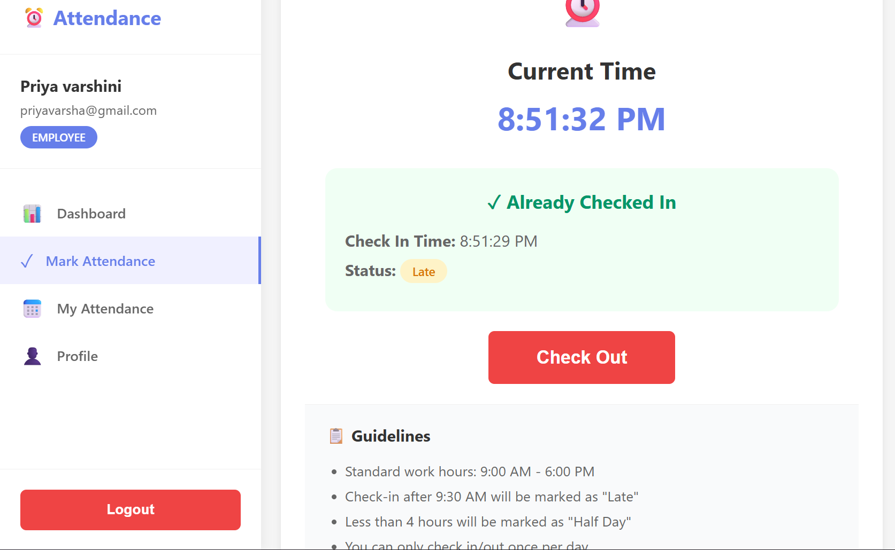

3.View my attendance history (calendar or table) and
View monthly summary (Present/Absent/Late days)
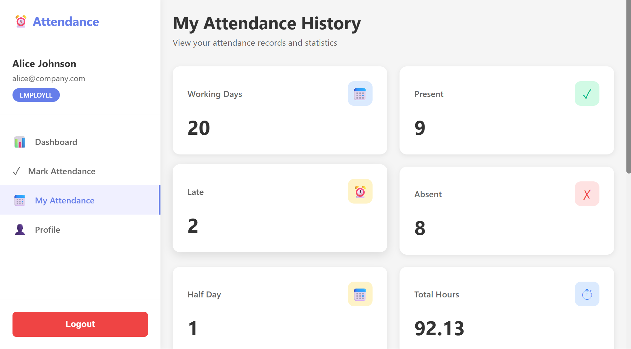

Color coded Calendar View
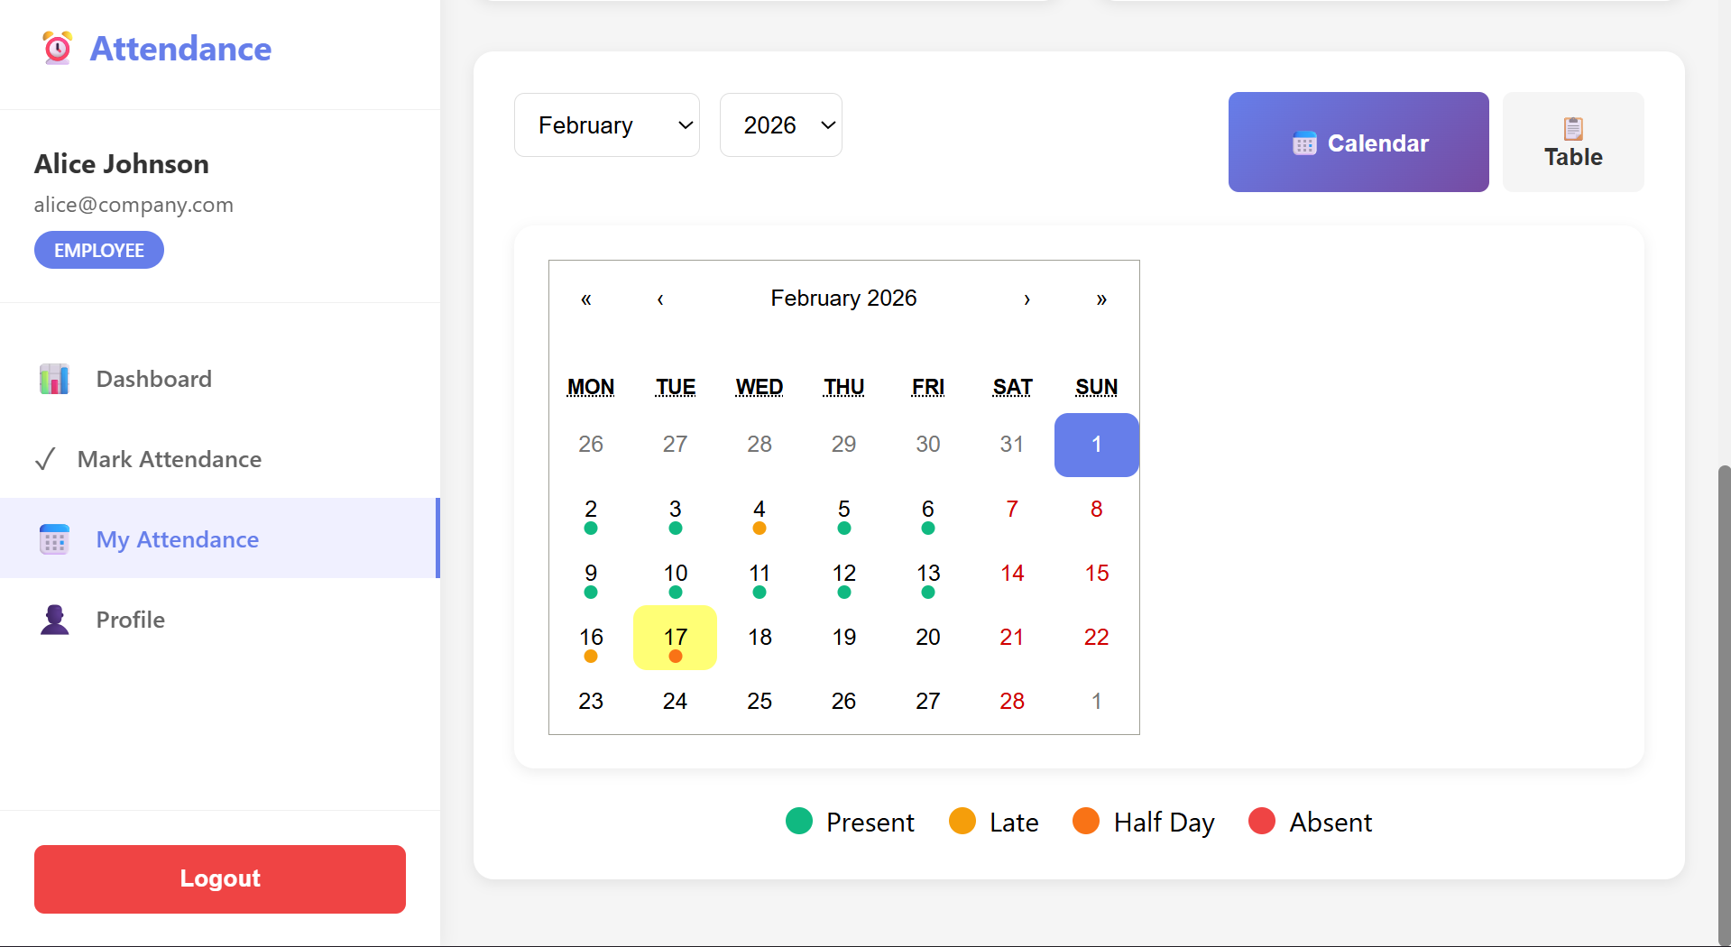

Table view
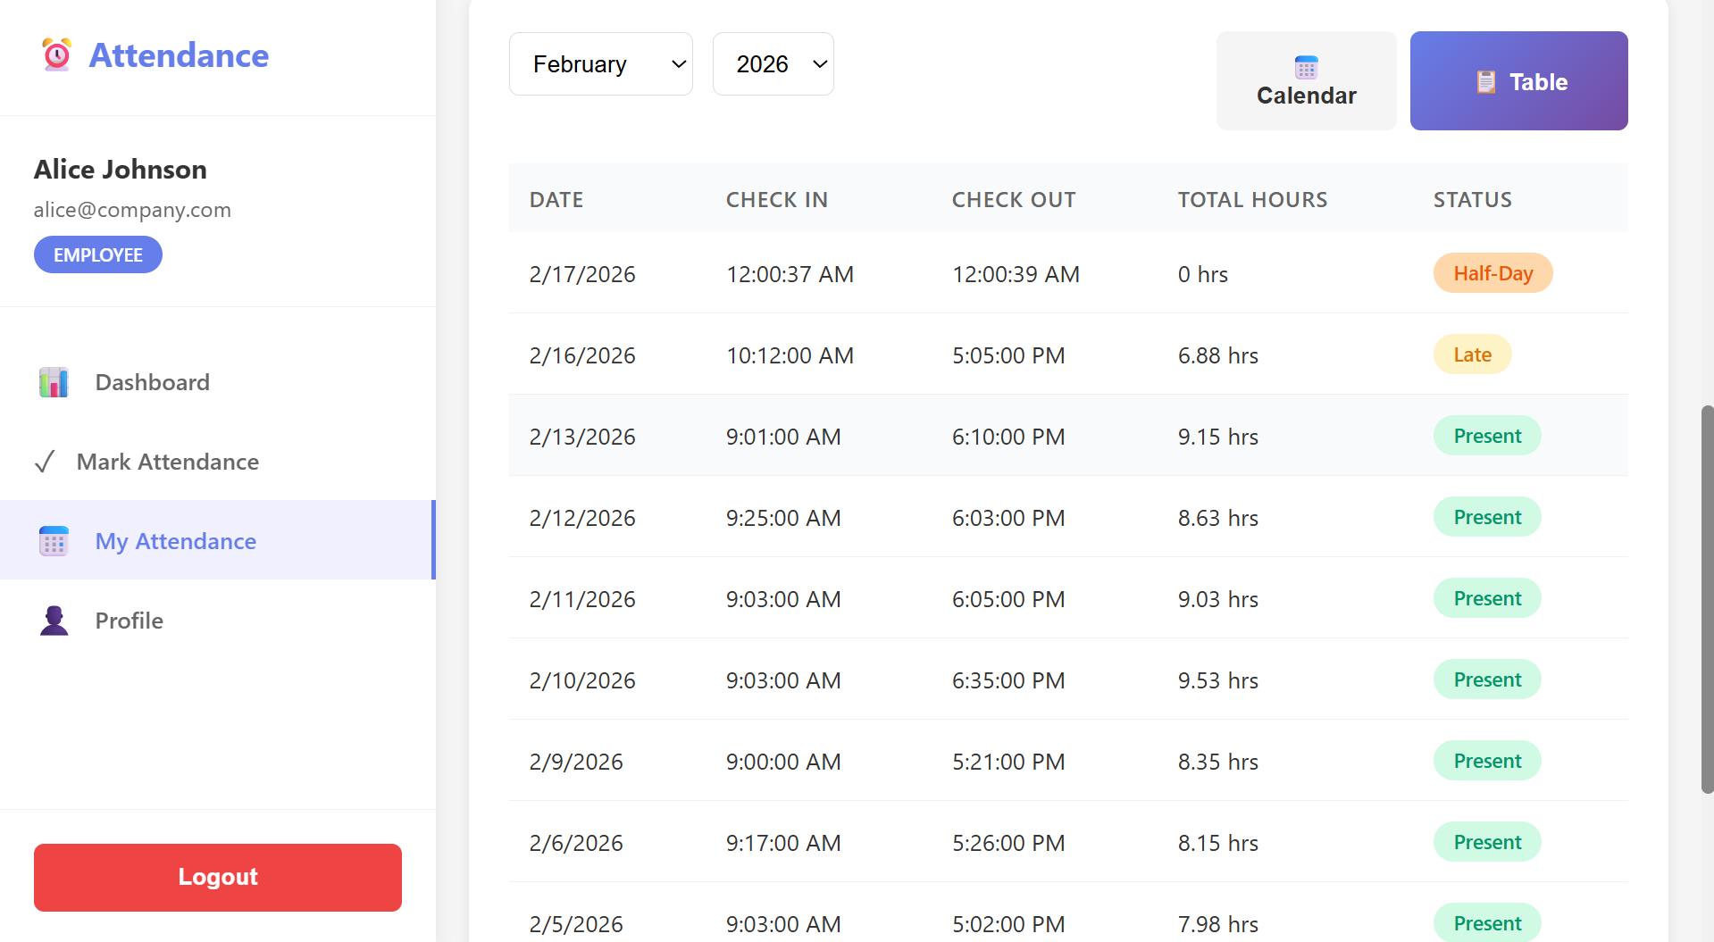

4. Dashboard with stats
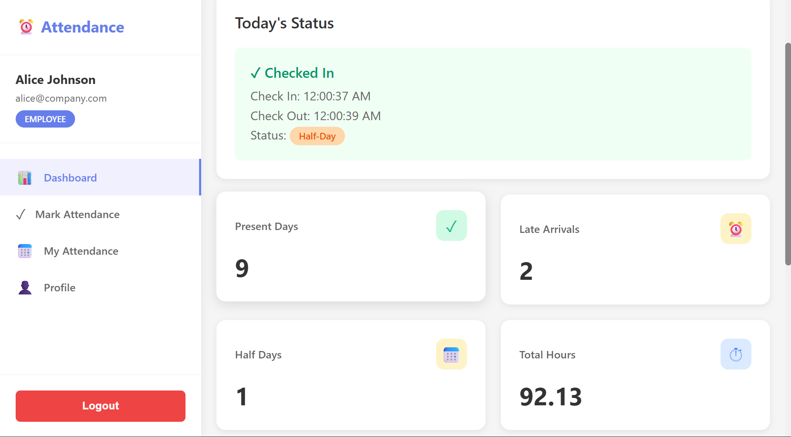
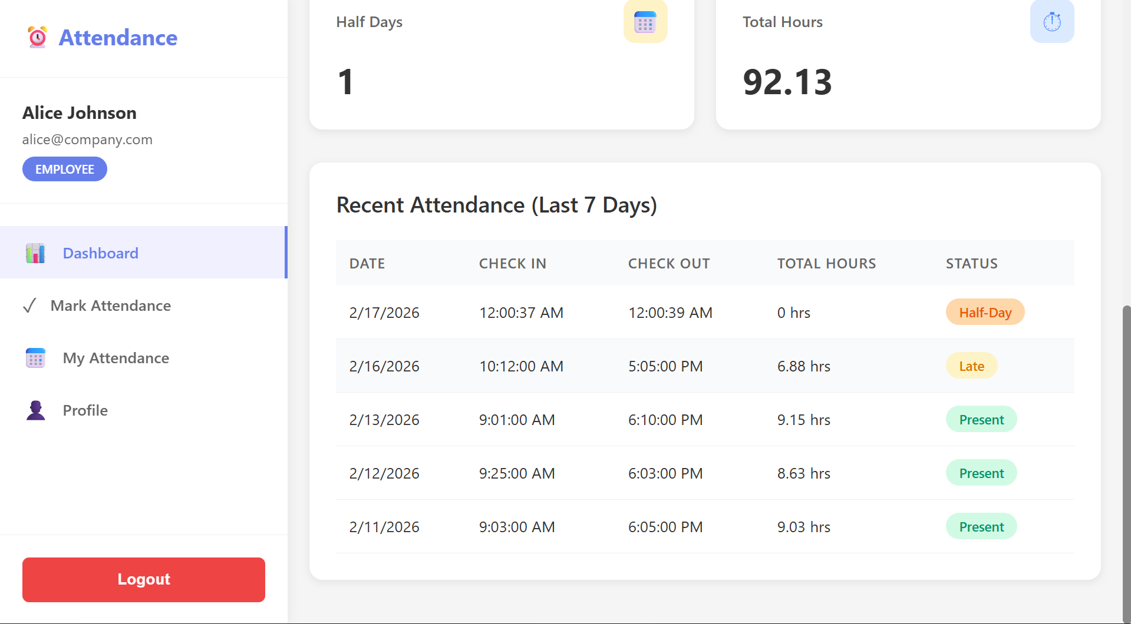

Profile
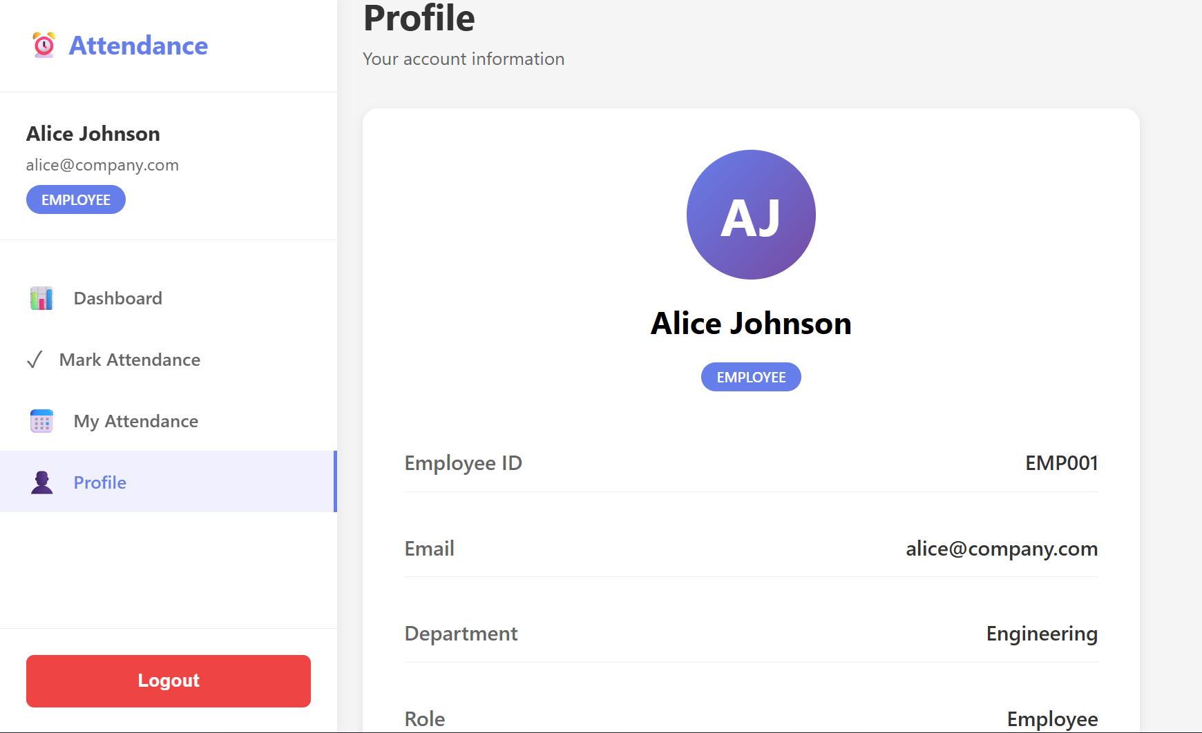

Back-End Testing
API Testing using Postman
API Endpoints
Auth
POST /api/auth/register
- Register API
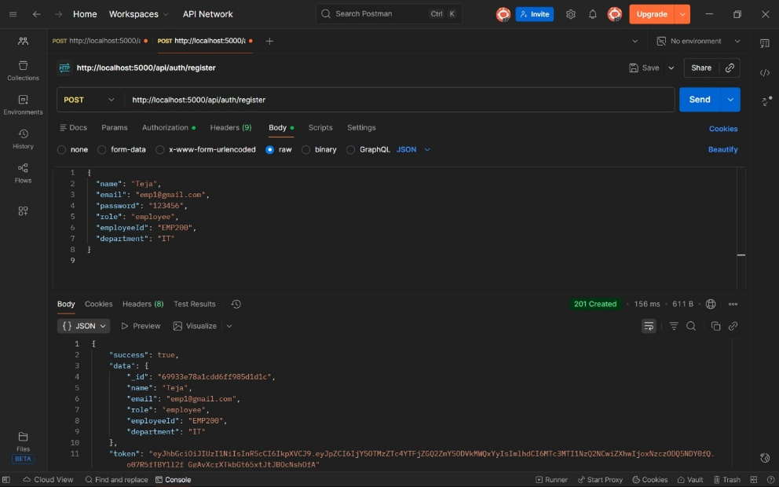
POST /api/auth/login
- Login API
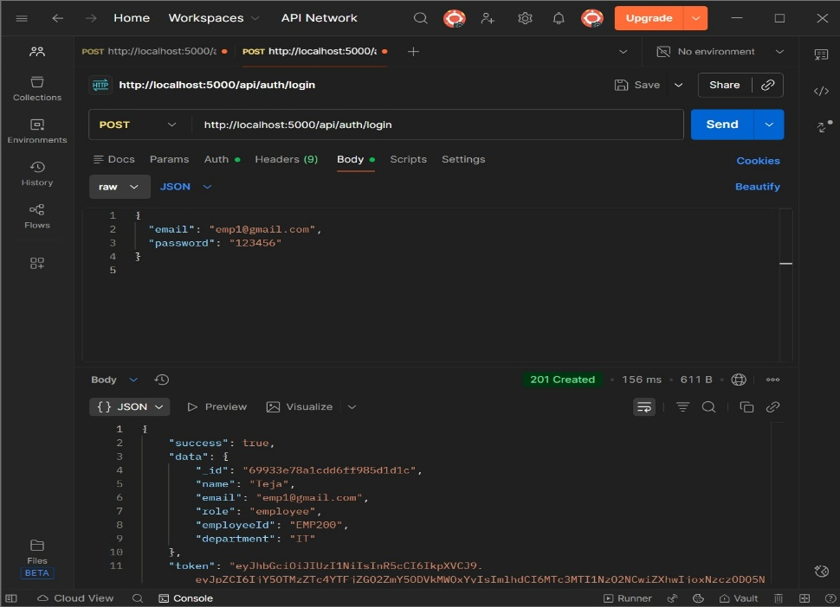

GET /api/auth/me
- Me
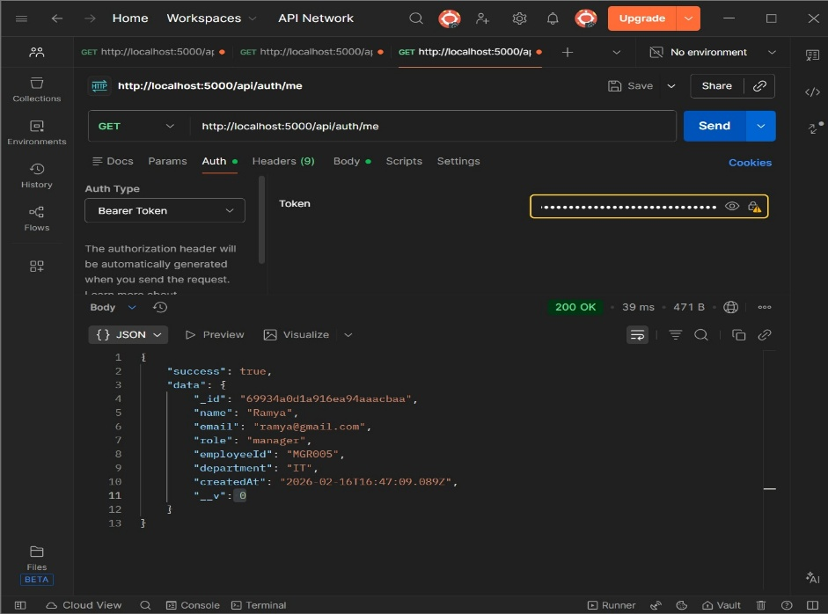

Attendance (Employee)
POST /api/attendance/checkin - Check in
- Check In API
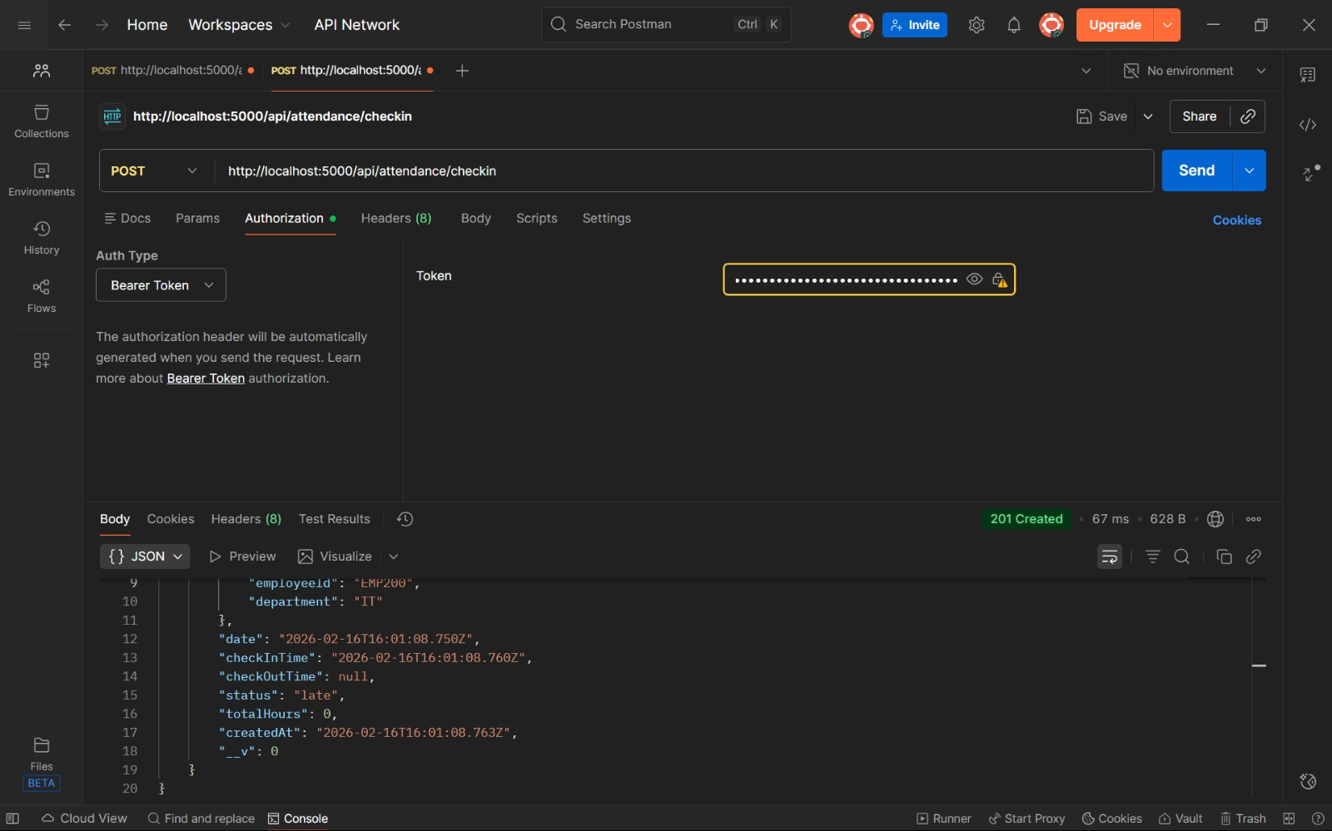
POST /api/attendance/checkout - Check out
- Check-out API
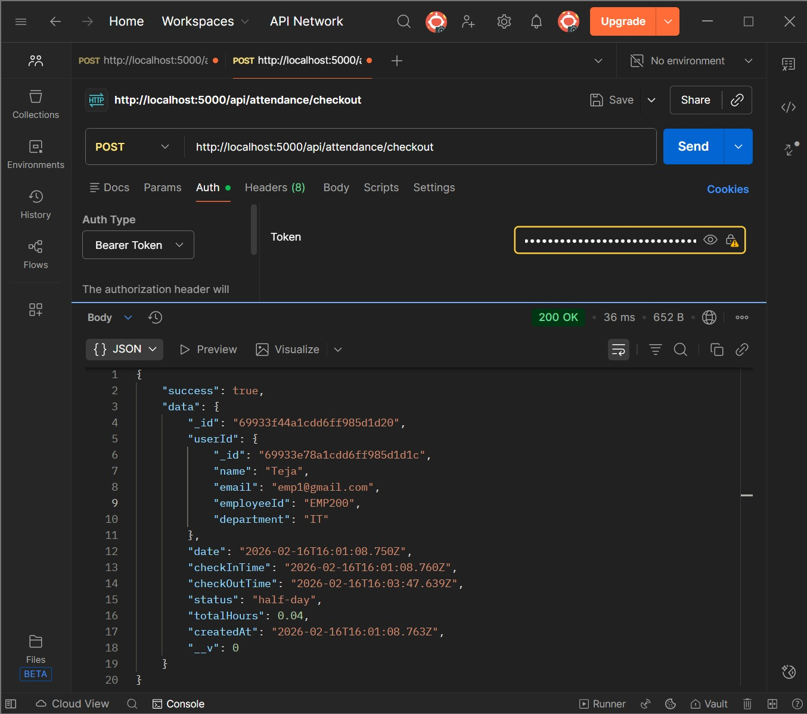
GET /api/attendance/my-history - My attendance
- My history
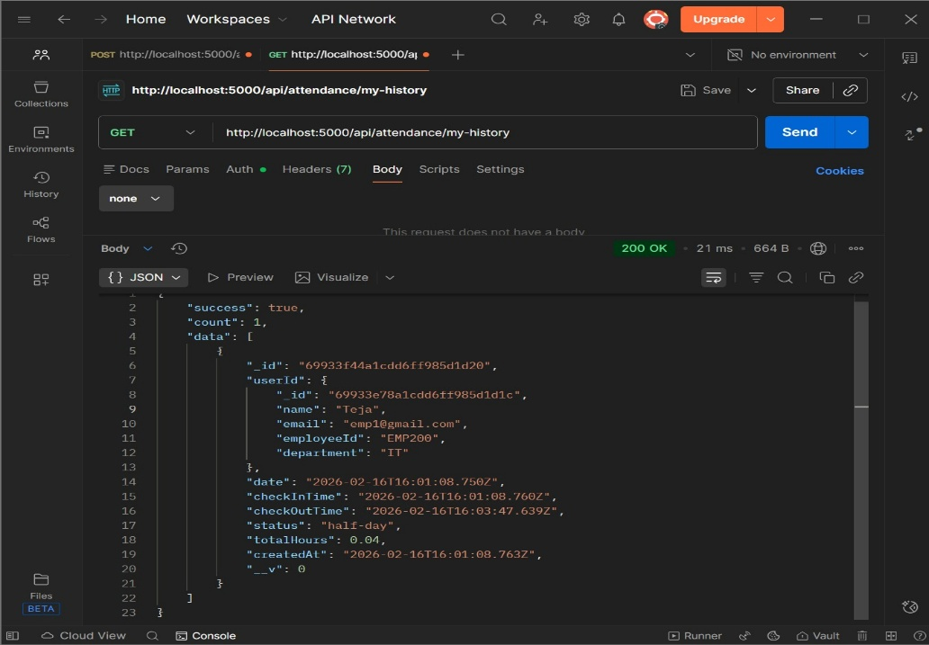
GET /api/attendance/my-summary - Monthly summary
- Monthly Summary
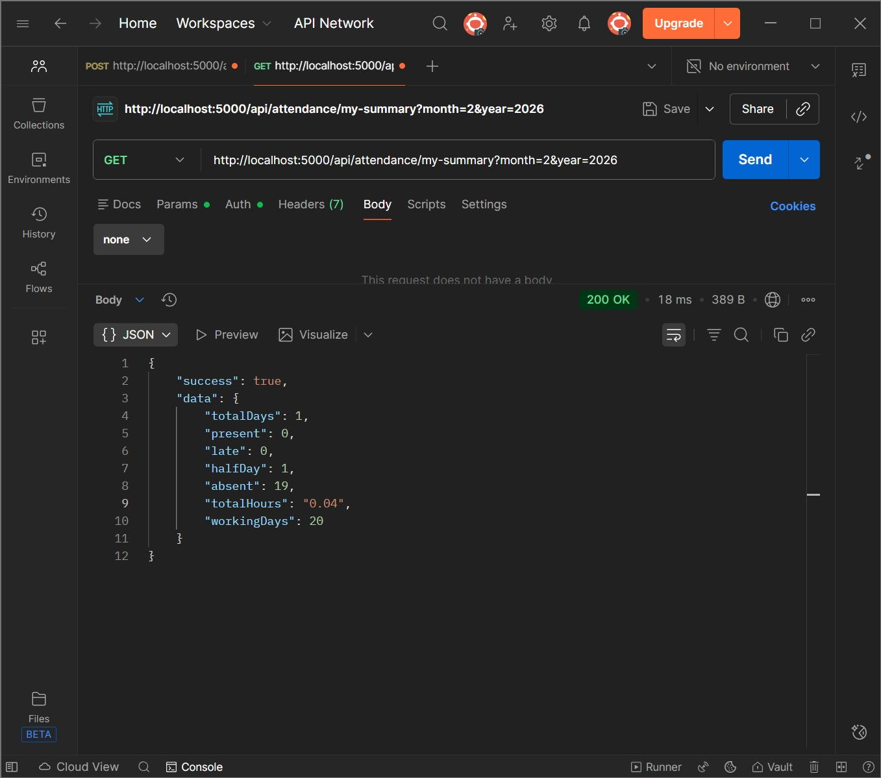

GET /api/attendance/today
- Today's status
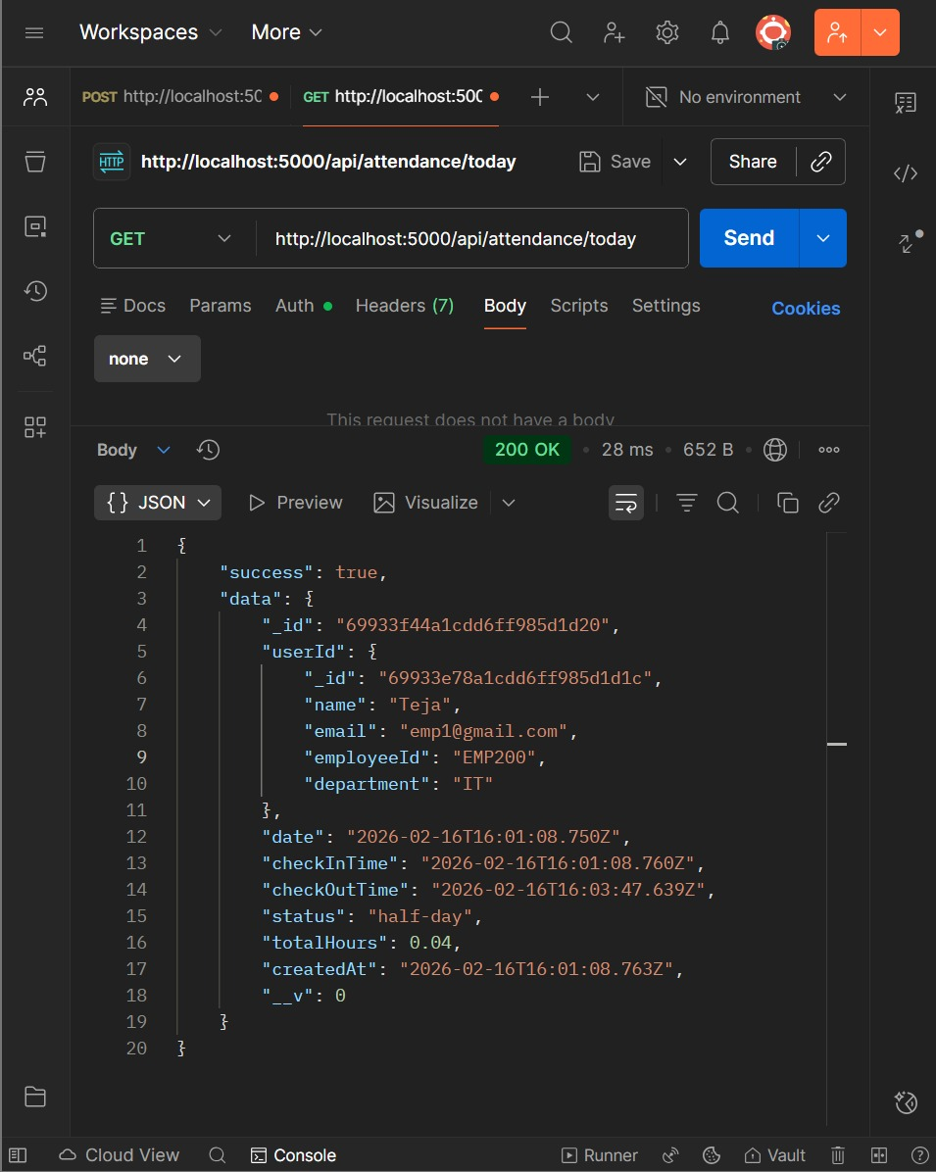

Attendance (Manager)
GET /api/attendance/all
- All employees

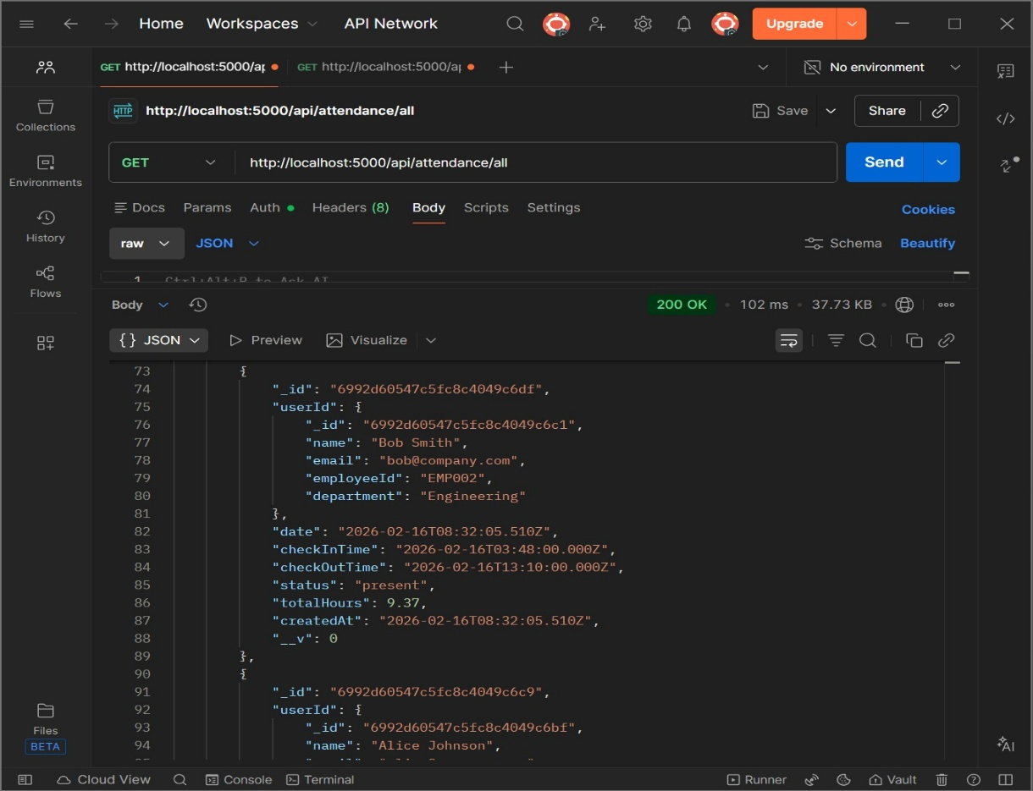
GET /api/attendance/employee/:id
- Specific employee
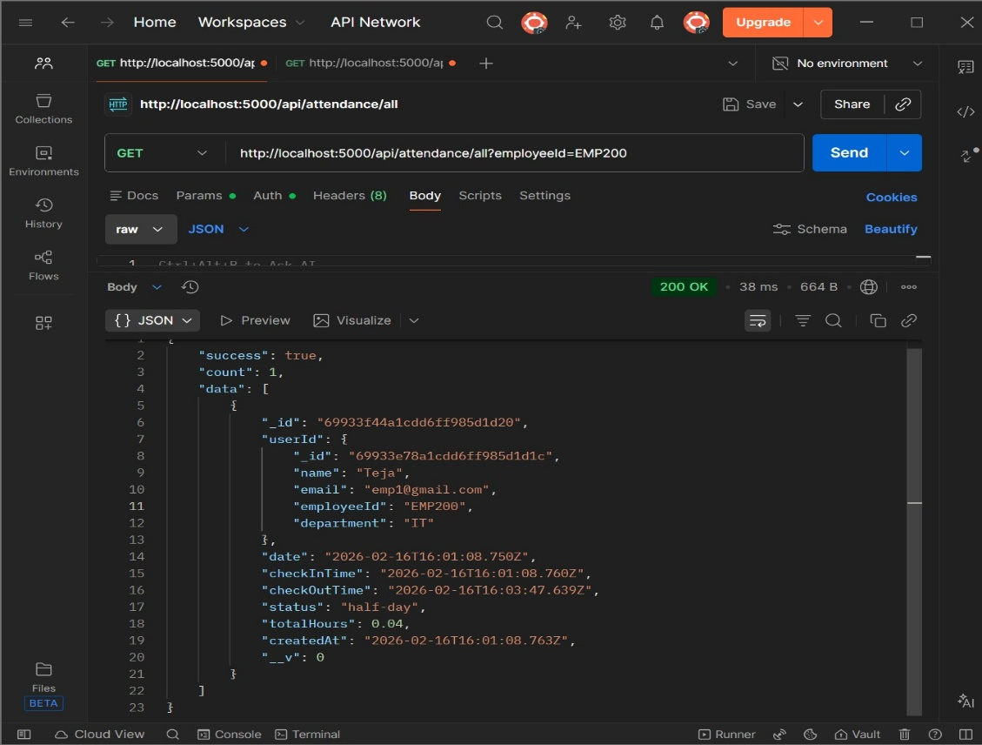
GET /api/attendance/summary
- Team summary
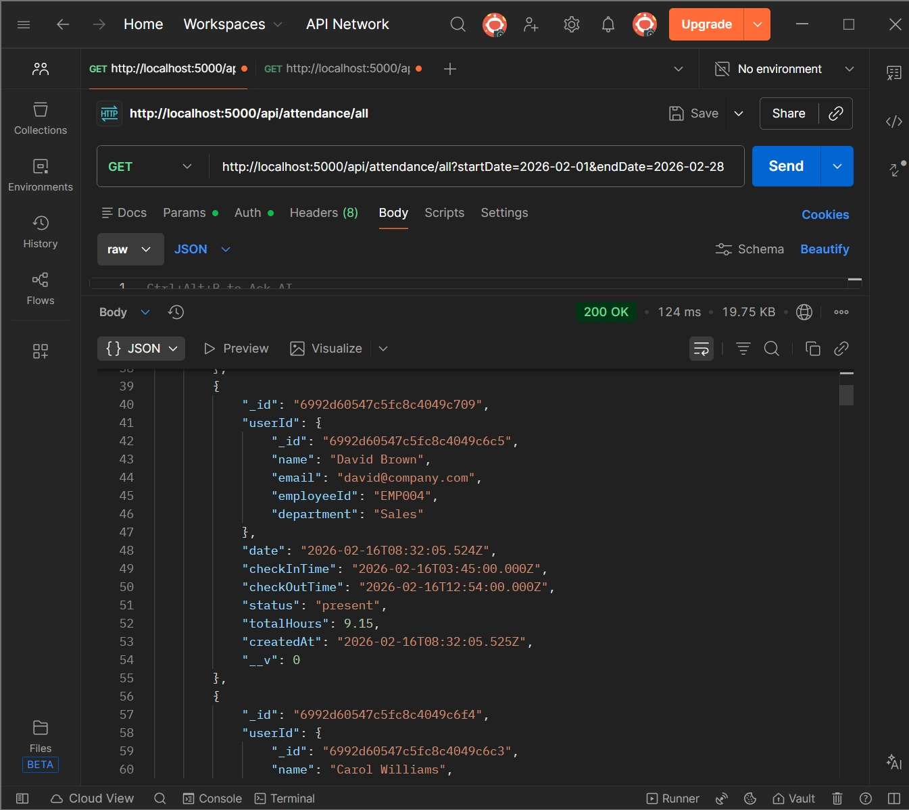

GET /api/attendance/export
- Export CSV
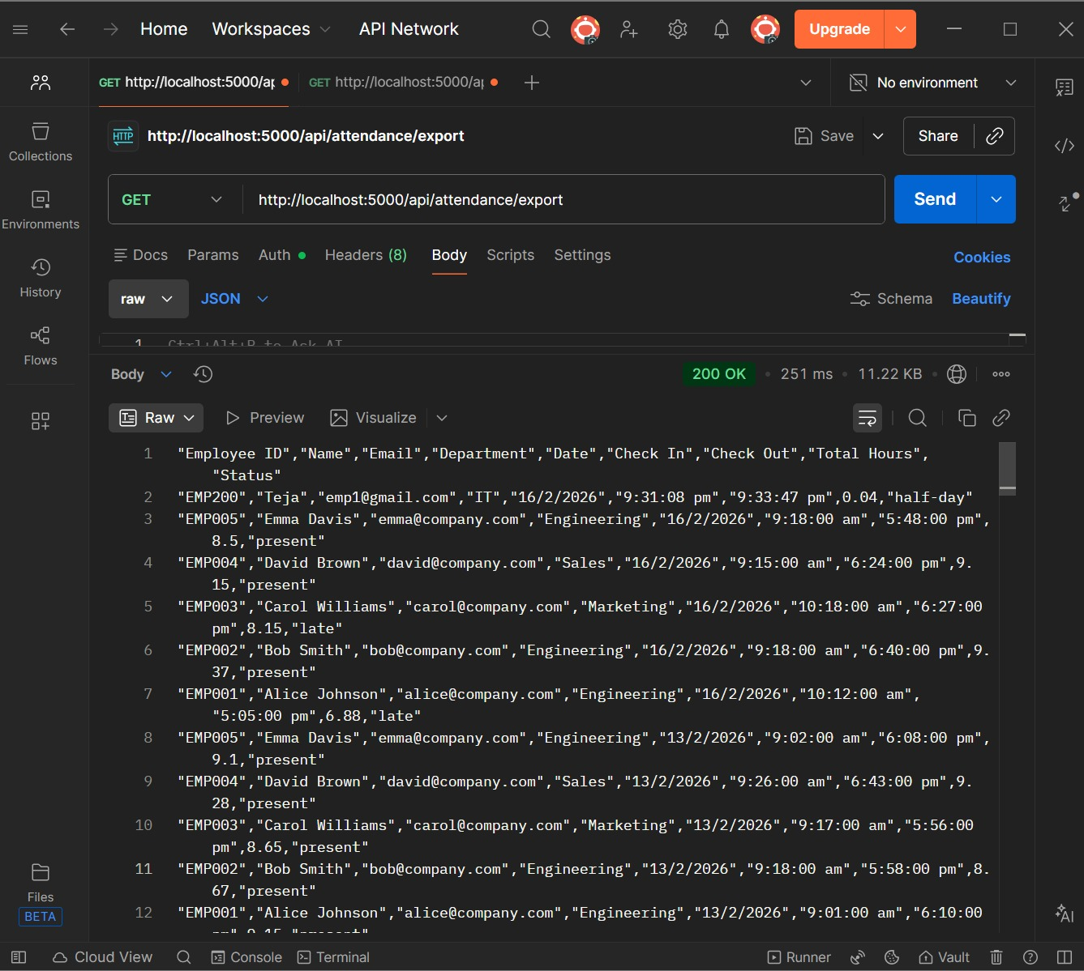

GET /api/attendance/today-status
- Who's present today
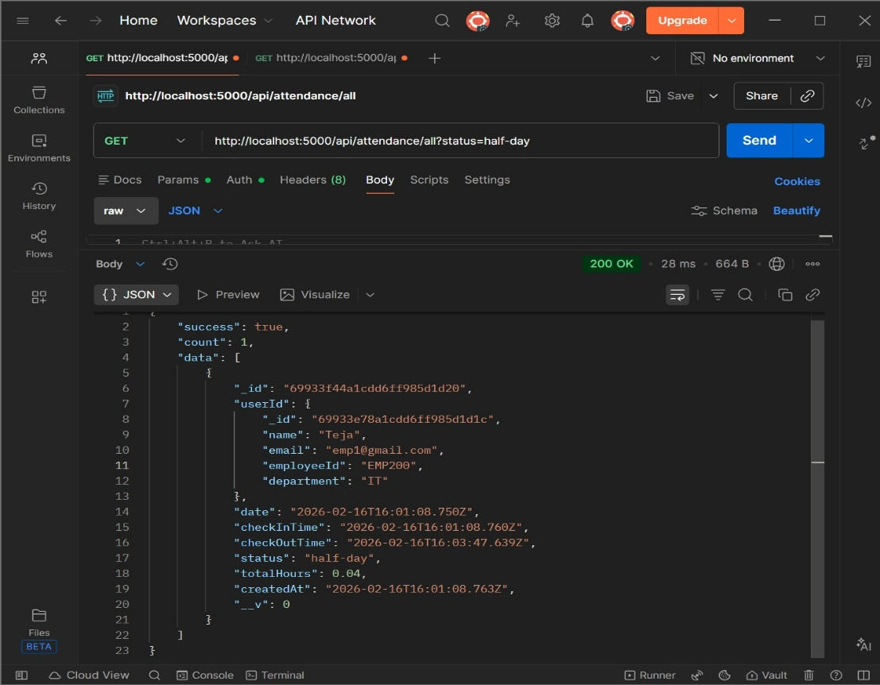
Dashboard
GET /api/dashboard/employee
- Employee stats
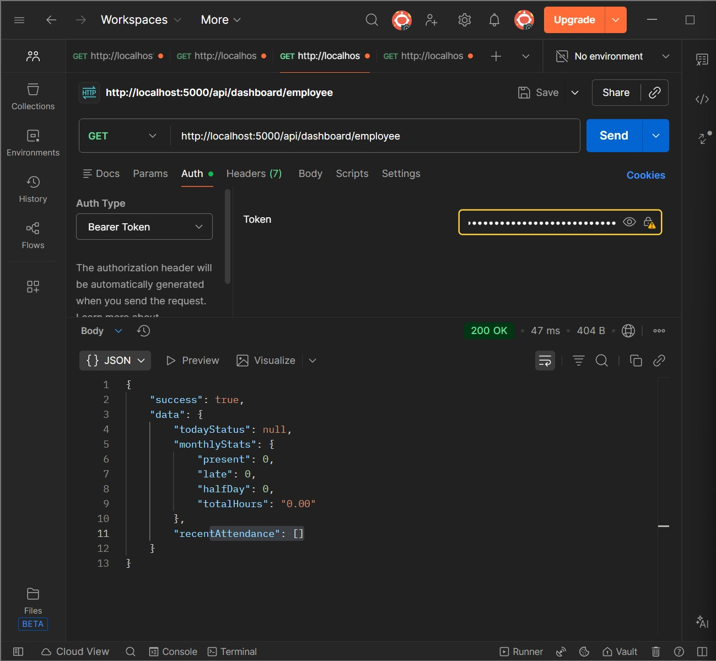
GET /api/dashboard/manager
- Manager stats
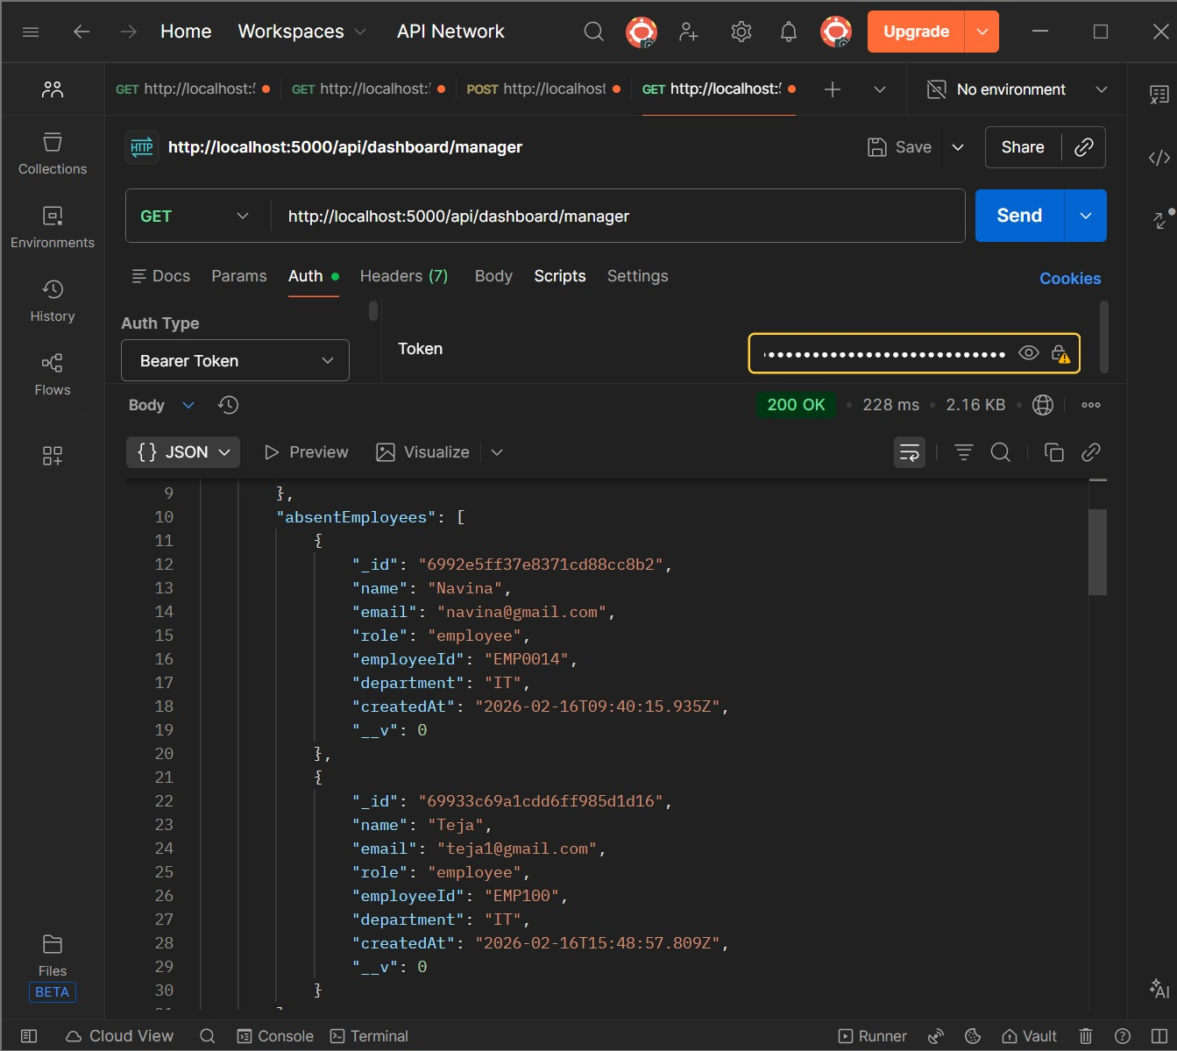

Database Schema
Users:
- id
- name
- email
- password (hashed)
- role (employee/manager)
- employeeId (unique, e.g., EMP001)
- department
- createdAt
User details in the MongoDB Database viewed using MongoDB Compass
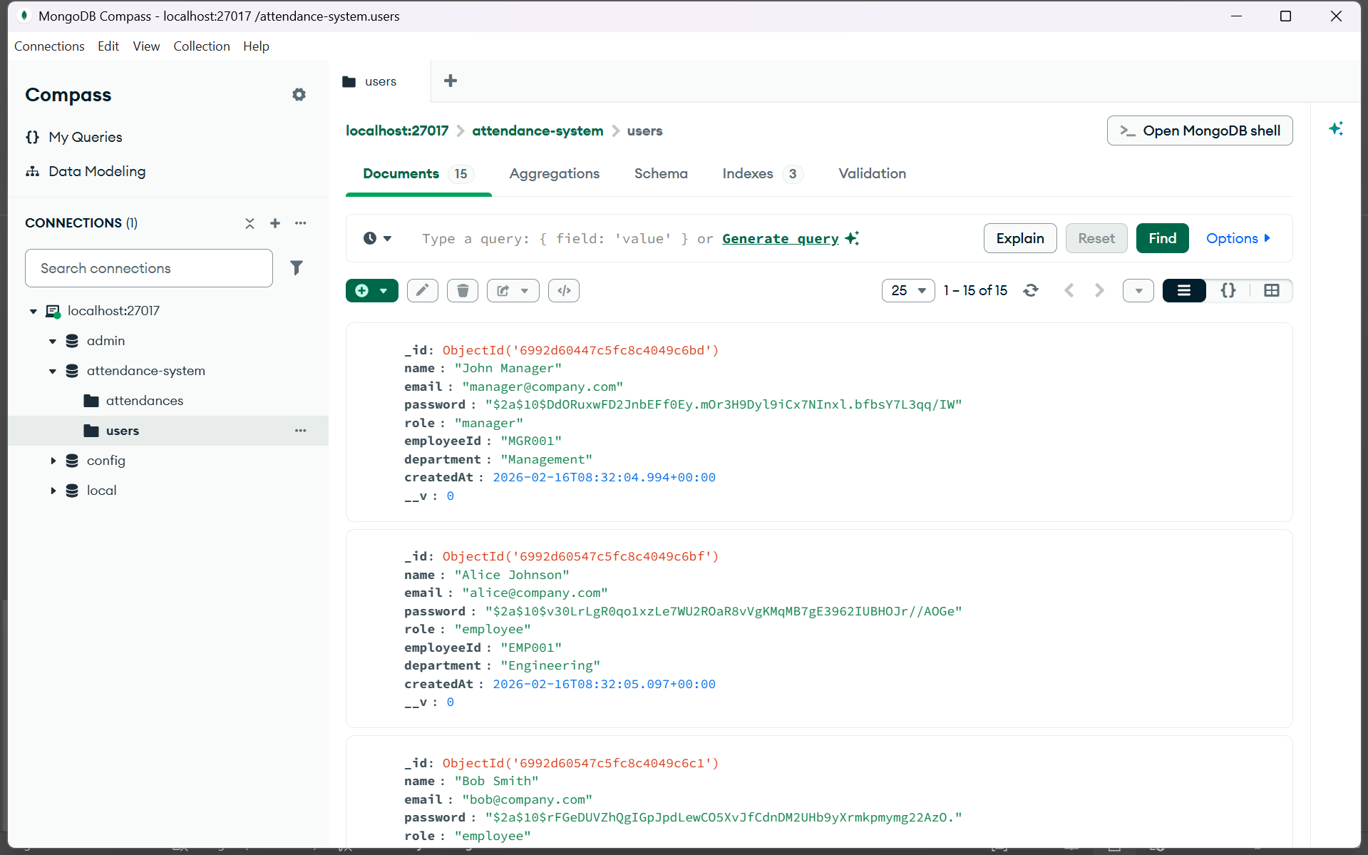
Attendance:
- id
- userId
- date
- checkInTime
- checkOutTime
- status (present/absent/late/half-day)
- totalHours
- createdAt

View of Attendance details
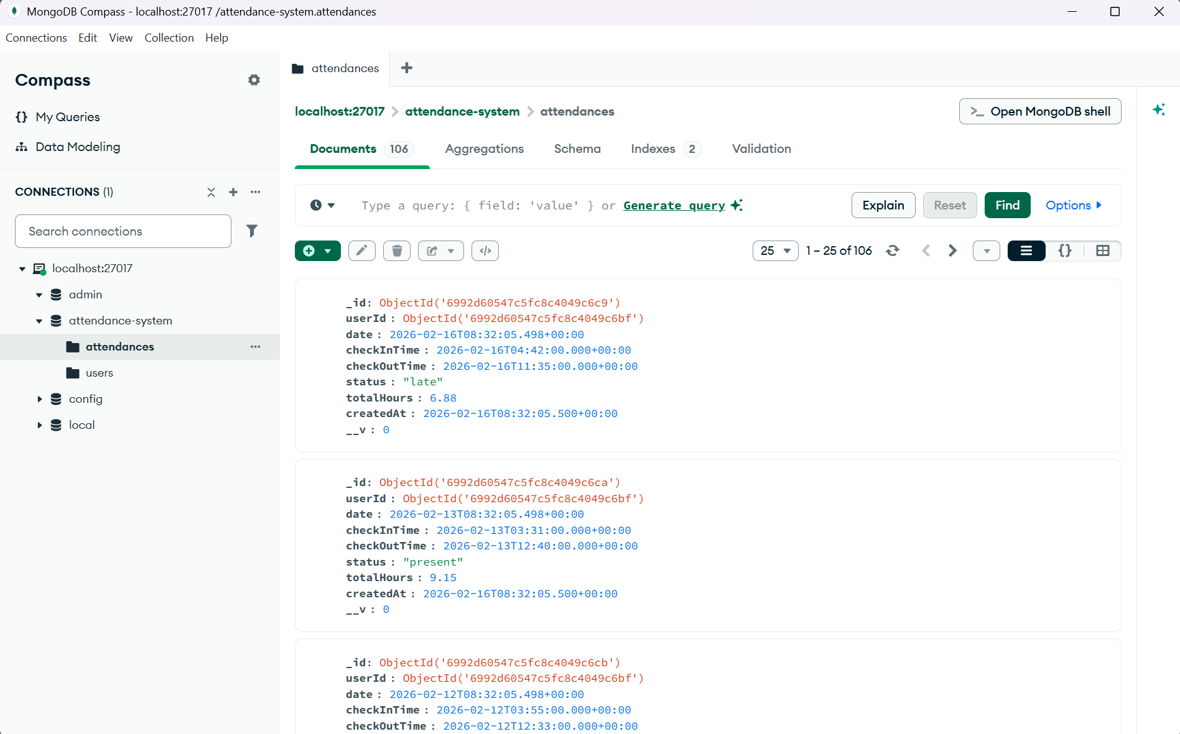

Seed data
Provided in code as seedData.js

NAME : R Tejashree
ROLL NO : VTU21891
COLLEGE : Vel Tech Rangarajan Dr. Sagunthala R&D Institute of Science and Technology
CONTACT : Vtu21891@veltech.edu.in
7010213425

